RR.java

**import** java.util.*;

**import** java.io.*;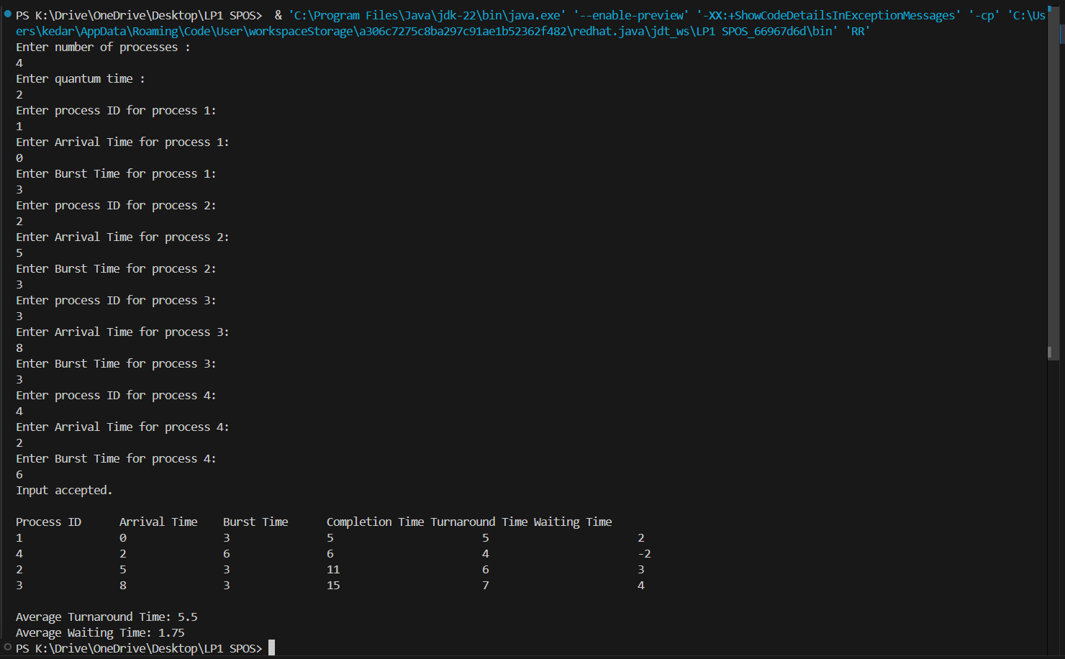

**public** **class** RR{

**public** **static** **void** main(String[] args) {

Scanner s = **new** Scanner(System.***in***);

System.***out***.println("Enter number of processes : ");

**int** n = s.nextInt();

System.***out***.println("Enter quantum time : ");

**int** q = s.nextInt();

**int** pid[] = **new** **int**[n];

**int** at[] = **new** **int**[n];

**int** bt[] = **new** **int**[n];

**int** ct[] = **new** **int**[n];

**int** tat[] = **new** **int**[n];

**int** wt[] = **new** **int**[n];

**int** rbt[] = **new** **int**[n];

**int** f[] = **new** **int**[n];

**float** avgwt = 0, avgta = 0;

**int** temp;

**for** (**int** i = 0; i < n; i++) {

System.***out***.println("Enter process ID for process " + (i + 1) + ": ");

pid[i] = s.nextInt();

System.***out***.println("Enter Arrival Time for process " + (i + 1) + ": ");

at[i] = s.nextInt();

System.***out***.println("Enter Burst Time for process " + (i + 1) + ": ");

bt[i] = s.nextInt();

rbt[i] = bt[i];

f[i] = 0;

}

System.***out***.println("Input accepted.");

// Sort processes based on arrival time

**for** (**int** i = 0; i < n; i++) {

**for** (**int** j = i + 1; j < n; j++) {

**if** (at[i] > at[j]) {

temp = at[i];

at[i] = at[j];

at[j] = temp;

temp = bt[i];

bt[i] = bt[j];

bt[j] = temp;

temp = pid[i];

pid[i] = pid[j];

pid[j] = temp;

}

}

}

// Implementing Round Robin Scheduling

**int** st = 0, tot = 0;

**while** (**true**) {

**boolean** done = **true**;

**for** (**int** i = 0; i < n; i++) {

**if** (at[i] <= st) {

**if** (rbt[i] > 0) {

done = **false**;

**if** (rbt[i] > q) {

st += q;

rbt[i] -= q;

} **else** {

st += rbt[i];

ct[i] = st;

rbt[i] = 0;

tot++;

}

}

}

}

**if** (done)

**break**;

}

**for** (**int** i = 0; i < n; i++) {

tat[i] = ct[i] - at[i];

wt[i] = tat[i] - bt[i];

avgta += tat[i];

avgwt += wt[i];

}

System.***out***.println("\nProcess ID\tArrival Time\tBurst Time\tCompletion Time\tTurnaround Time\tWaiting Time");

**for** (**int** i = 0; i < n; i++) {

System.***out***.println(pid[i] + "\t\t" + at[i] + "\t\t" + bt[i] + "\t\t" + ct[i] + "\t\t\t" + tat[i] + "\t\t\t" + wt[i]);

}

System.***out***.println("\nAverage Turnaround Time: " + (avgta / n));

System.***out***.println("Average Waiting Time: " + (avgwt / n));

s.close();

}

}

**OUTPUT:-**